**Banking Marketing Analysis**

# Introduction :-

This report presents a comprehensive analysis of the recent term deposit subscription campaign conducted via telephone marketing. The insights contained in this report are designed to empower management and the marketing team to make informed strategic decisions, allocate resources more effectively, and ultimately, increase the subscription rate for term deposit products.

The dataset used in this analysis contains a comprehensive collection of information of 41k individuals who have been contacted during the marketing. It encompasses a wide range of parameters, providing a detailed insight into the demographic details such as age, marital status, education level, offering a comprehensive overview of the sample population.

The dataset also delves into the previous campaigns and their outcomes, the subscription rate along with economic factors like consumer confidence index, Euribor rate for 3 months, consumer price index and employment variable rate which helps in the detailed analysis.

### Objectives :-

The primary objective of this analysis is to develop a deep, actionable understanding of the client characteristics, contact strategies, and external economic factors that drive the campaign performance. This report aims to:

* Identify the most promising client segments to target.
* Determine the optimal contact strategy and timing.
* Uncover the impact of macroeconomic conditions on consumer behavior.
* Provide the data-driven recommendations to enhance the efficiency and effectiveness of future marketing efforts.

### Tools Used :-

Tools used for Data Cleaning, Exploratory Data Analysis and Visualizations are as follows:-

* Excel
* Microsoft Power BI

## Key Findings :-

## 

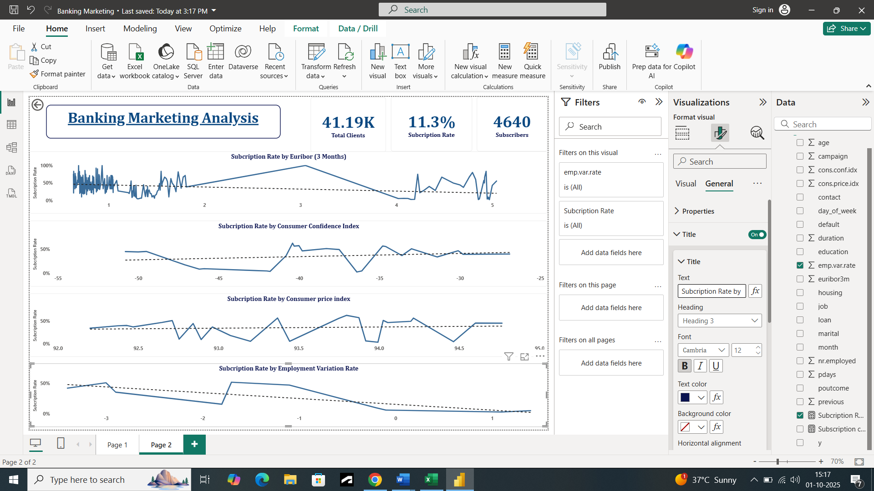

1. There are total **41k** clients with average age of 40 years included in this dataset.
2. Total number of subscribers is **4640** and Subscription rate for the term deposits for this period is **11.3%.**
3. There are some subscribers who have a personal loan and housing loan also. Usually, the people with any kind of loan avoid subscribing for term deposit because they have to pay the installments also, but this mainly depends on the income of the client. In this project, slicers for both personal loans and house loans are given to extract the information. **409** clients have both personal and housing loans and subscribed to the term deposit.
4. The donut chart provides details about the subscription by the status. Married people have the highest proportion (**56.62%**) among all the subscribers with **231** subscribers.
5. The scatter plot shows the correlation between the duration of call and the subscription rate. The higher the duration means higher the chances that the client will subscribe for the deposit.
6. The tree map shows the subscription rate by the previous campaign’s outcome. Success from the previous campaign has more chances that those clients will subscribe this time also.
7. **373** Subscribers with no default in credit constituting **12.6%** have subscribed the term deposit more as compared to clients having any default or unknown default status. **36** subscribers (**5%**) with unknown default status have subscribed also.
8. In the month of September and on Thursday highest number of subscriptions were made. There is a 100% subscription rate in September.
9. Mostly term deposits are adopted by the students and retired people. There are **275** students comprising **31.4%** and **434** retired people comprising **25.2%.**
10. Highest number of subscribers are in university degree category of education (**1670**), but if we see the subscription rate it is highest in the illiterate category (**22.5%**).
11. **Euribor Rate :**

The **Euribor** (Euro Interbank Offered Rate) is the average interest rate at which a large panel of European banks lend money to each other in the euro currency. When Euribor is low, Banks can borrow money from each other cheaply. When Euribor is high, It becomes more expensive for banks to borrow money. It is a fundamental benchmark that influences almost all interest rates in the Eurozone, from savings accounts and mortgages to loans and term deposits. In this analysis, the subscription rate fluctuates a lot with the Euribor rate at its minimum. The subscription rate is **100%** when the Euribor rate is **0.93**. It shows that there is a negative correlation between both, when Euribor is less subscriptions are high and vice versa.

1. **Consumer Confidence Index :**

The Consumer Confidence Index is a monthly survey that measures how optimistic or pessimistic consumers are about the economy's future health and their own personal financial situation. With high CCI, Consumers are**optimistic**. They feel secure in their jobs, expect their incomes to rise, and believe the economy is strong and with low CCI**,** Consumers are **pessimistic**. They are worried about their job security, expect their finances to worsen, and are cautious about the economy. So, there is a positive correlation between the subscription rate and the CCI. Highest subscription rate is **62.7%** at CCI of **-40.40**.

1. **Consumer Price Index:**

The Consumer Price Index (CPI) measures the average change over time in the prices paid by urban consumers for a market basket of consumer goods and services. Rising CPI means inflation is high. The cost of everyday items like food, housing, transportation, and healthcare is going up. Stable/Falling CPI (Low/Decreasing) means inflation is low and stable. Prices are not increasing rapidly. CPI tracks the erosion of purchasing power. If your income stays the same but CPI rises by 5%, you can buy 5% less with your money. In this analysis, It is showing an increasing trend along with the increasing CPI. The highest subscription rate is **62.7%** at **93.80** CPI.

1. **Employment Variation Rate :**

The Employment Variation Rate is a quarterly indicator that measures the change in the number of employed people. It tracks whether employment is growing or shrinking in the economy. If it is Positive = Accelerating (Economy adding jobs), if it is Negative = Braking (Economy losing jobs). It has a negative correlation with the subscription rate. As it is growing, subscription rate is declining.

Highest subscription rate is **52.1%** at **-1.70** employment variation rate.

## Conclusion :-

In conclusion, the analysis reveals clear patterns in client behavior and economic influence on term deposit subscriptions. To enhance campaign effectiveness, it is recommended to:

1. Main target should be high-conversion segments like students, retirees, and previously successful clients.
2. Proper evaluation of clients with unknown default status as we cannot directly exclude them.
3. Aligning marketing intensity with optimal timing, particularly the month of September and periods of low Euribor/high consumer confidence and other economic factors.
4. Optimize telemarketing strategy to foster longer, more engaging calls. For example -For the illiterate segment, use simple, visual, and verbal explanations and for the highly educated, provide detailed, data-driven fact sheets.

By implementing these data-driven recommendations, the bank can significantly improve subscription rates and allocate its marketing resources more efficiently.

## 